App Research

The purpose of this research is to guide developers to create a budgeting app that is relevant and competitive to the current personal finance space. Below we discuss the information collected studying You Need A Budget, X and X. Finding their main objectives, strengths, weaknesses and unique features.

- You Need A Budget
All available funds get budgeted towards an expense category based (Feasible Creative,2024).
User check their plan before spending to ensure they spend within set limit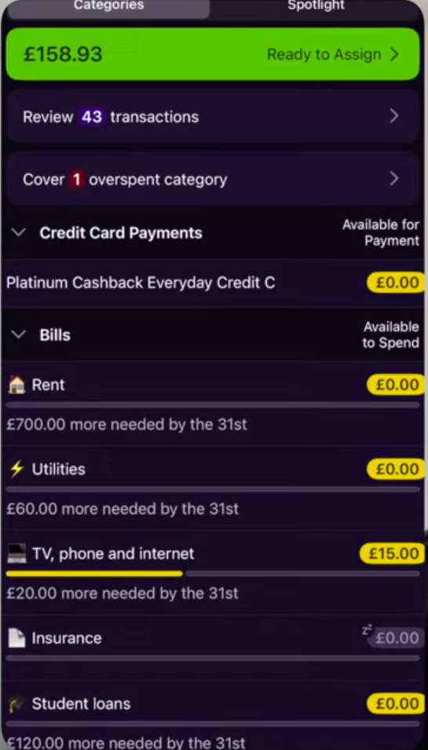 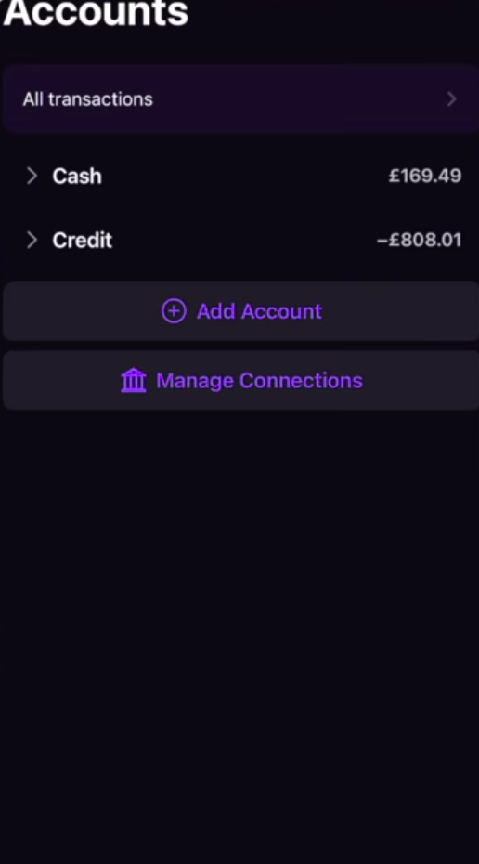 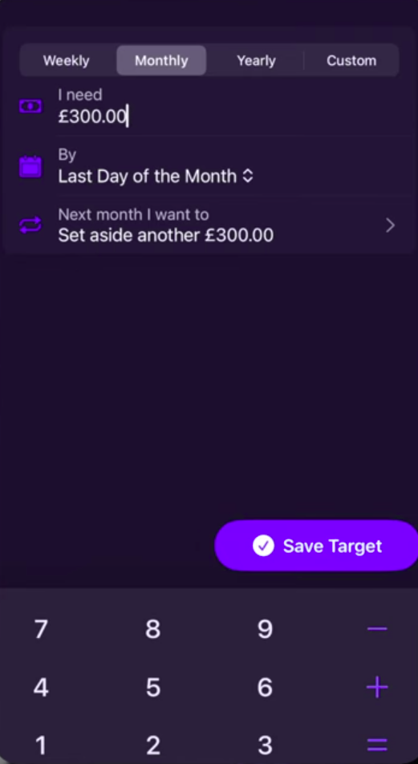
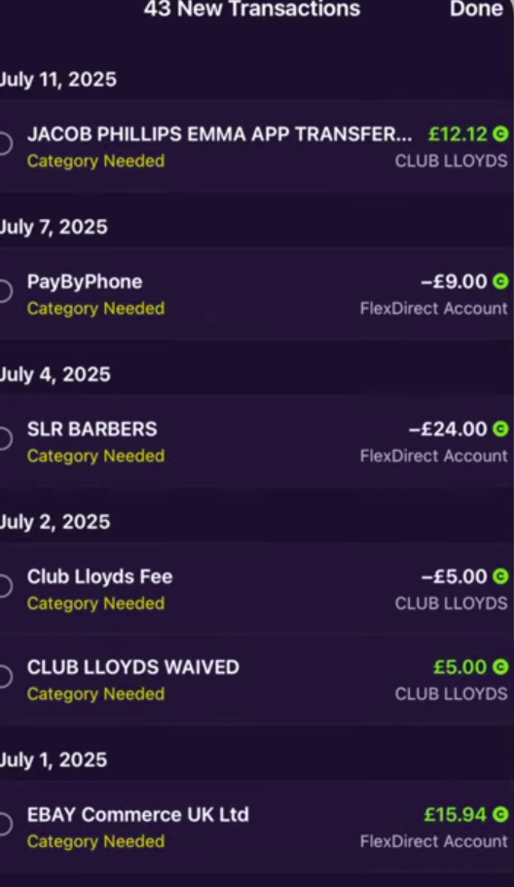
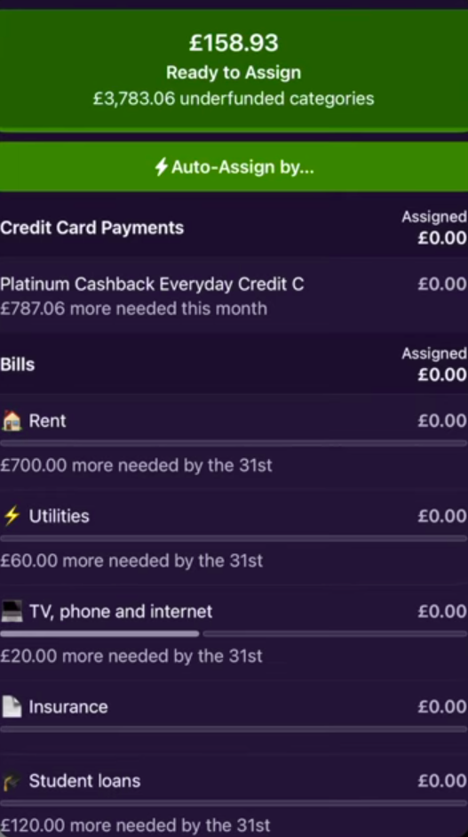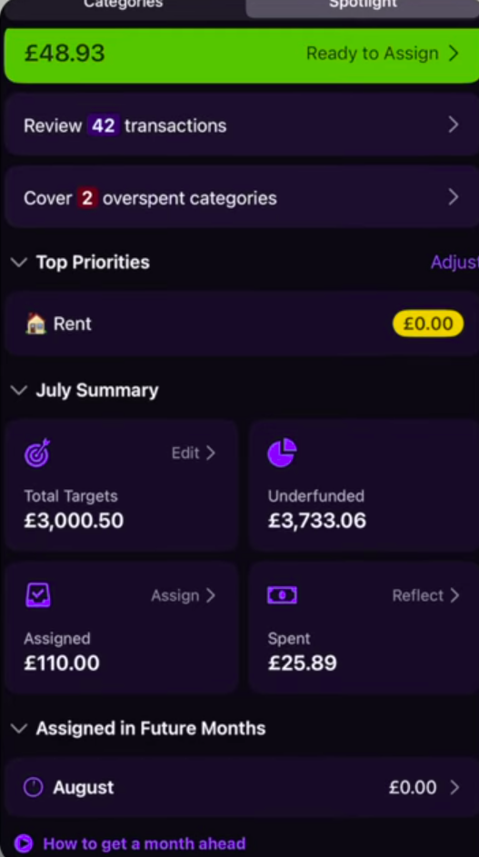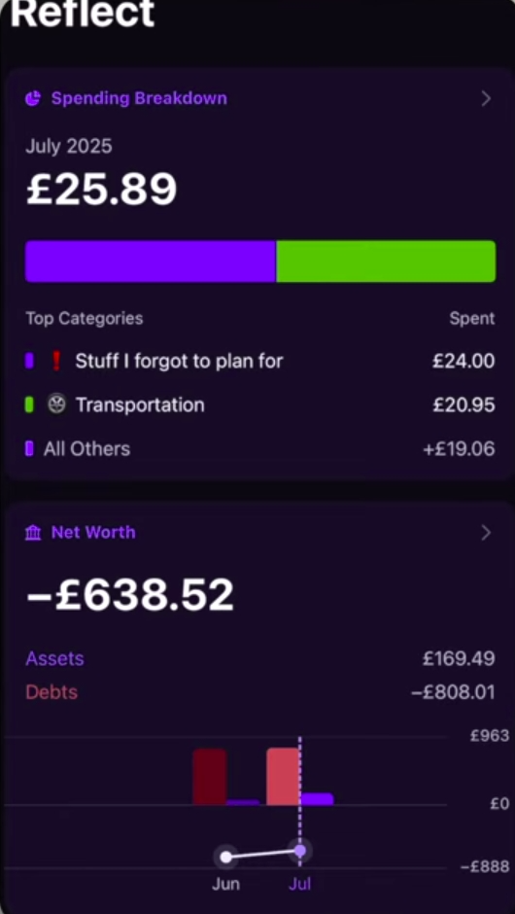
Accounts Screen. Connected accounts where income and expenses come from
Main screen. At a glance user see’s categories, budgets, progress and actions required
Setting a budget screen. Setting amount and frequency of budget cycle
Review transactions screen
Auto assign budget to expense categories
Spot light screen – reports and summaries of expenses
Strengths
Multiple Device and bank sync – A single account can have multiple devices and can be connected to several bank accounts. Income and expenses are automatically uploaded to the app (Feasible Creative,2024).The user still needs to log to avoid double billings and encourages users to become aware of their finances (Feasible Creative,2024).
Mobile and web support – users can access the platform on mobile and web browsers making uploading expenses very convenient. Reports on mobile are simple and easy to navigate (Feasible Creative,2024).
Flexible budgeting – large expenses are broken down into monthly budgets. Money overspent in a one category can be removed from a different category for breakeven. User can budget for multiple items under the same category (Feasible Creative,2024)
Ex. Bills category can have a budget for phone payment, rent and utilities (Feasible Creative,2024).
Weakness
No support of investment tracking – no real-time tracking of volatile assets such as crypto, stocks and other commodities real time. Therefore, user doesn’t get a holistic view of all the accounts
Learning curve - App doesn’t guide users through how to use it. By using it like a tracker it becomes hard to actually use the app (Feasible Creative,2024).
Load speed – the app pushes all transactions to memory to perform current calculations. Over time this would cause very slow load speeds, online reviews show this.
Uniqueness
- Common Goal – multiple users can add funds to a shared account (Feasible Creative,2024).
- Forsee expenses – user sets budgets for large future payments (insurance, renews, payments) automatically the app creates a budget spread across a period of time to allow user to budgeted (Feasible Creative,2024)

- Public API – large pools of user made wrappers and integrations into already apps. Allows YNAB to integrate into other tools and user can create
- Money age – income is timestamped. The longer the app stays in the account the more “ages”. This gamification tool encourages good financial discipline by prompting users to save and not take in new expenses (Feasible Creative,2024)

- App X
- APP Y

Features from the app to include in our own
- Money ageing – time stamping budgets to allow users to see how long they saved their money
- Creating multiple budgets under the same category/ sub categories.
- Automatic breaking down of financial saving target to track user progress over a period of time
The current financial budget space have several options for a variety of budgeting styles. After analyzing the pitfalls and strengths of the apps mentioned above development can start. The best features such as breaking down of expenses, xxx, xxxx will be a starting block for development.
A major goal is to fulfill all functional requirements while avoiding the same weaknesses found in the apps researched to create a comprehensive budgeting app

Reference List
Feasible Creative,2024.YNAB Budget App: What I Wish I Knew Before Starting.[video online] Available at: https://www.youtube.com/watch?v=mqB_Vu2_le0 [Accessed 24 February 2026].
(Feasible Creative,2024)
Jacob Phillips,2025.YNAB Tutorial & Honest Review (2025) | Complete Setup Guide & Pro Budgeting Strategies.[video online] Available at: https://www.youtube.com/watch?v=6smi9S8Rm7s&list=TLPQMjQwMjIwMjaQEQBlrtAcdA&index=3 [Accessed 24 February 2026]

